Preparing your Manuscript for AES Technical Reviews Journals, Conference Proceedings and Transactions
First A. Author ¹*, Second B. Author ², Third C. Author ³
¹ Dept. of Mechanical Engineering, University of Ottawa, Ottawa, Canada K1N 6N5
(Email: @ )
² Laboratories of Composite Materials, University of Ottawa, Ottawa, Canada, K1N 6N5
(Email: @ )
³ Dept. of Civil Engineering, University of Ottawa, Ottawa, Canada, K1N 6N5
(Email: @ )
*Corresponding Author

Abstract
Use 8.5” x 11”(letter) size paper. All margins should be, for all pages, 0.8” (top), 0.6” (bottom), 1.2” (left) and 1.0” (right), with 0.0” (gutter) and “Portrait” orientation. The text should be laid out in two equal columns The text, within a column, should be single line spacing and fully (left and right) justified and aligned.
The entire text must be prepared in Times New Roman font. Use 16 point font for the title, 12 point bold font for the name(s) of author(s) and main headings, 11 point font for author(s) affiliation(s), subheadings and the main text.
The title of the article, name(s) of authors and their affiliation(s) should appear, centered in the first page, in small letters with only the first of each letter is capitalized.
All names of the authors should be in bold and appearing on the same line, separated by comma. First name, middle initial and last name should be given for all authors. Addresses of authors must be centered immediately after the author(s) name(s) on the first page.
Please provide an abstract at the beginning of the text which would reflect the content of your article. The abstract text should contain between 120 and 150 words. Use 12 point italic (bold) Times New Roman font for the heading and 11 point italic Times New Roman font for the main text.
Keywords
Provide five to ten keywords. Keywords must be separated by commas.

1 Typeface
1.1 Headings and subheadings
All main headings (Abstract, Keywords,
Introduction, … , References) should appear in bold and in small letters with only the first letter of each word is capitalized. Use 12 point font for the main headings.
Subheadings should appear also in bold and in small letters with only the first letter of the subheading is capitalized. Use 11 point font in the subheadings. Typing must start on the line immediately after the heading and subheading, with one single line space separating the main sections of the text.
Please don’t indent lines or paragraphs within the main text of the article. Main section headings and headings of subsections, however, must be indented 14.4 pt. from their respective numbers. The same must apply to the reference listing at the end of the article.

1.2 Equations
Equations must be typed in letter size font comparable to those used in the main text, i.e. 11 point Times New Roman (in Microsoft Word or compatible software). Equations must start from the left hand side of the column, and numbered in sequence, with each equation number between parentheses positioned flush with the right hand side of the column. Please make sure that the equations are apparent from the text by leaving one space above and below each equation if it would be necessary. Please use, beside the conventional mathematical symbols, Latin and Greek letters only.

2 Photographs, Figures, Graphs and Tables
All photographs, figures, graphs and tables must be included within the text of the article. They should be in a digital form and in a manner ready for reproduction as part of the text.
All tables, photographs, figures and graphs must be centred within column width, with at least one space line separating each from the above and below text.

Table 1. Errors in determining three different
discrete dynamic systems.
First | Second | Third
0.852E -2 | 0.253E 0 | 0.634E-1

Acknowledgments
Acknowledgments, if any, should appear immediately after the “Conclusions” section, and immediately before the section of “References”.

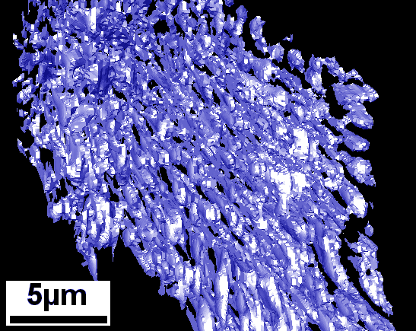
Figure 1. 3D-structure of eutectic Si in an AlSi7Sr alloy (Voxel size = 59x75x114 nm³).

References
All references must be in 11 point Times New Roman. They should be listed immediately after the pertinent section-heading “References”. All references should be numbered sequentially as they appear in the main text of the article. In the list of references, an indentation of 14.4 pt. should be used to separate each reference from its number. Reference number should appear positioned in square brackets in the main text and also within the list of references. The references should be given in the styles shown below, for books, proceedings and journals, respectively.
[1] Haddad, Y. M. (2001), Mechanical Behaviour of Engineering Materials. Kluwer (Springer), Dordrecht, The Netherlands.
[2] Axelrad, D. R., Haddad, Y. M. (1997), In Proceedings NATO ARW, Kiev, Ukraine, Advanced Multilayered and Fibre- Reinforced Composites, pp. 163-172, Haddad, Y.M. (Ed.). Kluwer (Springer), Dordrecht, The Netherlands.
[3] Molina, G. J., Haddad, Y. M. (2001) On the design of acousto-ultrasonics / pattern recognition classifiers for the identification of material response states, J. Mech. Beh. of Mater., 12 (5), 255 – 72.

